**IDEATION PHASE**

**Brainstorm & Idea Prioritization**

| Date | 25-06-25 |
| --- | --- |
| Team ID | LTVIP2025TMID31256 |
| Project Name | CRM Application for Jewel Management (Developer) |

**Brainstorm & Idea Prioritization Template:**

Brainstorming encourages a collaborative environment where developers, business analysts, and end-users contribute creative ideas to enhance CRM capabilities specific to jewel management. The goal is to generate innovative and actionable ideas that streamline customer engagement, order tracking, and inventory handling—leading to a polished CRM solution tailored for jewelry retail and service.

**Step-1: Team Gathering, Collaboration and Select the Problem Statement**

**Objective:** Assemble a cross-functional team and define the core problem areas in jewel business CRM systems.

**Problem Statement:** Current CRM systems used by jewel businesses lack tailored features for managing personalized customer interactions, tracking high-value inventory, and automating service and order workflows, resulting in customer dissatisfaction and operational inefficiencies.

**Activities:**

* Gather team members: Developers, UI/UX designers, jewel sales experts, business analysts.
* Use collaboration tools like Miro or Figma for remote ideation.
* Define scope: Focus on customer profile management, purchase history, custom order tracking, and loyalty programs.
* Assign roles: A facilitator to drive discussions and a scribe to document key inputs.

**Step-2: Brainstorm, Idea Listing and Grouping**

**Objective:** Generate and categorize a wide range of ideas to address the unique CRM needs of a jewel management system.

**Process:**

* Conduct a 20-minute brainstorming session encouraging creative and specific ideas.
* Capture ideas using sticky notes or a virtual whiteboard.
* Group ideas under the following categories:

**Feature Categories:**

1. **Customer Relationship Management:**
   * Loyalty program integration
   * Personalized product recommendations
   * Anniversary and festival reminders
2. **Inventory & Order Management:**
   * Real-time inventory tracking of high-value items
   * Custom order tracking (design, status, delivery)
   * Barcode/RFID-based stock updates
3. **Sales & Support Automation:**
   * AI chatbots for customer queries
   * Auto-generated quotations and invoices
   * After-sale service workflows
4. **Analytics & Reports:**
   * Customer purchase trends
   * Stock movement reports
   * ROI on marketing campaigns

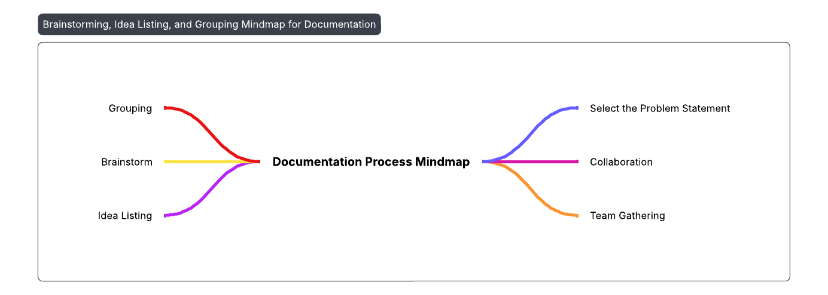

**Step-3: Idea Prioritization**

**Objective:** Rank the generated ideas based on business impact, ease of development, and cost.

**Process:**

* Use a prioritization matrix (Impact vs. Effort or Cost vs. Value).
* Score ideas from 1 to 4 on the following parameters:

| **Criteria** | **Definition** |
| --- | --- |
| **Impact** | Improves customer satisfaction or business operations (1 = Low, 4 = High) |
| **Feasibility** | Ease of development within project timeline (1 = Difficult, 4 = Easy) |
| **Cost** | Budget requirements for implementation (1 = High, 4 = Low) |

### 

## 📊 Developer Pictograph: CRM for Jewel Management

### 🤔 Think & Feel:

* **Robust & Scalable CRM: 💪 Wants to build a strong, future-proof system.**
* **Integration Concerns: 🔗 Worried about connecting with existing POS (Point of Sale) and ERP (Enterprise Resource Planning) systems.**

### 👂 Hear:

* **Jewelers' Needs: 🚀 Feedback for simpler, faster systems.**
* **Customer Demands: 🔒 Requests for personalization and secure data handling.**

### 👀 See:

* **Competitor Apps: 💅 Slick interfaces but weak backend integration.**
* **Mobile CRM Trend: 📱 Growing use of mobile solutions in luxury retail.**

### 🗣️ Say & Do:

* **Code Quality: ✍️ Develop secure, efficient, and modular code.**
* **Rigorous Testing: 🧪 Test features thoroughly to prevent live bugs.**